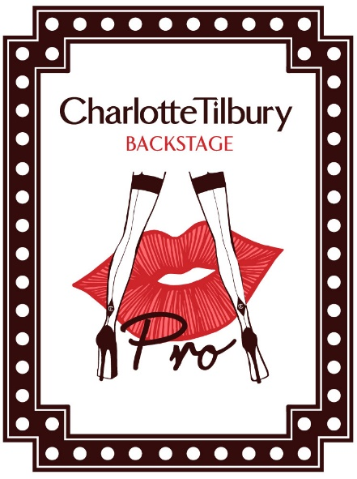
CHARLOTTE TILBURY PRO APPLICATION FORM

To apply to join Charlotte Tilbury’s PRO Makeup Artist Program, please enter your details below and send this form, along with the required documentation, to pro.applications@charlottetilbury.com

First Name

Last Name

Email Address

Country of Residence

Home Telephone Number

Mobile Telephone Number

Date of Birth (DD/MM/YYYY)

Address
Are you a Charlotte Tilbury Employee? | □ Yes □ No
Are you already a customer on Charlottetilbury.com? | □ Yes □ No
Have you applied to Charlotte Tilbury PRO before? | □ Yes □ No
What is your favourite look? | □ The Ingénue  □ The Golden Goddess  □ The Uptown Girl  □ The Sophisticate  □ The Rock Chick  □ The Dolce Vita  □ The Bombshell  □ The Vintage Vamp  □ The Glamour Muse  □ The Rebel
What product(s) do you use the most? | □ Skincare  □ Foundation  □ Powder  □ Concealer  □ Blush  □ Bronzer / highlighter  □ Eye shadow  □ Eyeliner  □ Mascara  □ Lip care  □ Lip liner  □ Lipstick  □ Lip Gloss  □ Brow  □ Primer  □ Makeup Remover

